Bansilal Ramnath Agarwal Charitable Trust’s
VISHWAKARMA INSTITUTE OF TECHNOLOGY, PUNE-37

(An Autonomous Institute of Savitribai Phule University)

Department of Artificial Intelligence & Data Science

Division | AIDS-A
Name | Atharva Raut
Roll.no | 21
PRN | 12310801
Batch | B-1

Assignment No. 2

Title: Execution of advanced linux commands

Description

- Ls
The ls command is used to list the contents of a directory. It displays information about files and directories within the specified directory. Various options can be used with ls to change the output format, such as showing detailed information, sorting, and including hidden files.

Syntax: ls [options] [file...]

- Ps
The ps (process status) command provides a snapshot of the current processes running on the system. It can show various details about these processes, such as PID (process ID), TTY (terminal type), time, and command that initiated the process. Options allow you to filter and display specific information about the processes.

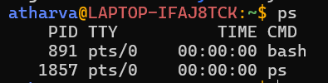

- Pwd
The pwd (print working directory) command outputs the full pathname of the current working directory. It is useful for determining your current location within the filesystem hierarchy.

Syntax: pwd [options]

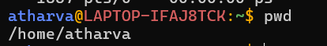

- cat
The cat (concatenate) command is used to display the contents of a file, concatenate multiple files, and redirect output in terminal. It is often used to quickly view the contents of a file or to combine several files into one.

Syntax: cat [options] [file...]

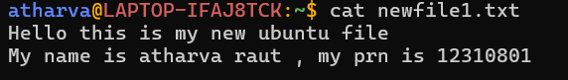

- kill
The kill command is used to send signals to processes, typically to terminate them. By default, it sends a SIGTERM signal, which gracefully stops a process. The -9 option sends a SIGKILL signal, which forcefully stops the process immediately. You can specify the process to kill by its PID.

Syntax: kill [options] pid

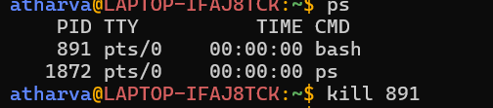
(No output if successful)

- sleep
The sleep command is used to delay execution for a specified amount of time. It accepts arguments in seconds, minutes, hours, or days. This command is useful in scripts where you need to introduce pauses or delays between commands.

Syntax: sleep [number][suffix]

- wait
The wait command waits for a background process to complete. It is often used in shell scripts to pause execution until specified background jobs have finished. The wait command can take a PID as an argument to wait for a specific process, or it can wait for all background processes if no PID is provided.

Syntax: wait [pid]

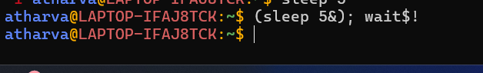
(No output, just waits for 10 seconds)
Syntax: service [service_name] [command]

- grep
The grep (global regular expression print) command searches for patterns within files. It prints lines that match the given pattern, which can be specified using regular expressions. grep is a powerful tool for searching and filtering text. Options allow you to make the search case-insensitive, search recursively, count matches, and more.

Syntax: grep [options] pattern [file...]

- chmod
The chmod (change mode) command is used to change the file access permissions for the owner, group, and others. Permissions determine the read, write, and execute rights for a file or directory. The command can set permissions using symbolic or numeric modes, allowing fine-grained control over who can access and modify files and directories.
Syntax: chmod [options] mode[,mode] file1 [file2 ...]

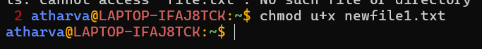

- service
The service command is used to start, stop, restart, or check the status of system services on Unix-based systems. It provides a standardized way to manage services across different Linux distributions. The command typically requires root privileges.

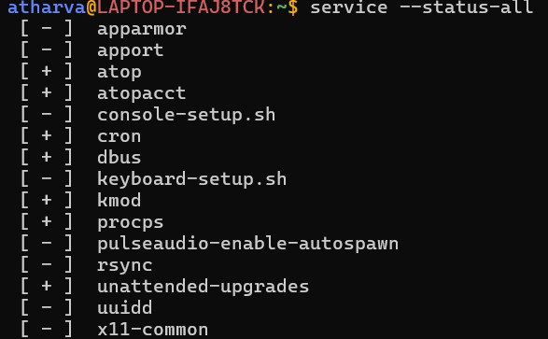

Syntax: service [service_name] [command]

